Acid & Base

1. a) Define Acid and Base with explanation.

b) Define pH and indicator with two examples.

c) Solve problem: The pH of HCl is 2. Find out the amount of acid present in a liter of the solution.

a)

An acid is a molecule or ion capable of either donating a proton (i.e. Hydrogen ion H+). Known as an acid (Bronsted Lawry acid)

A base is any molecule or ion that can accept proton.

For example, when dry HCl gas dissolve in water, each HCl molecule donate a proton to water molecule to produce Hydrogen ion.

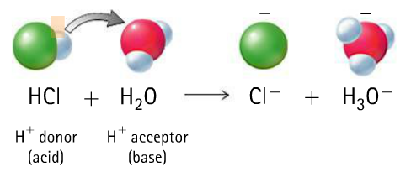

When Calcium oxide is dissolve in water, it is converted to Calcium Hydroxide, Ca(OH)2. Here a water molecule donate a proton to oxide ion, O2-, and is a Bronsted acid, the oxide ion accepts a proton and gives, 2OH- ions, hence is Bronsted base.

O2- + O3H ------------> 2OH-

b)

**pH:** Hydrogen ion concentration of a solution is called pH. I is defined as the negative of base – 10 logarithms of H+ concentration.

**Indicator:** pH indicators are weak acids that exist as natural dyes and indicate the concentration of H+ (H3O+) ions in a solution via color change. A pH value is determined from the negative logarithm of this concentration and is used to indicate the acidic, basic, or neutral character of the substance you are testing.

**Examples:**

1. Phenolphthalein
2. Methyl red, and
3. Bromothymol blue

c)

Sln:

pH = 2

* Log [H+] = 2 --------------------- (by definition)

The dissociation of HCl takes according to equation:

HCl ------------> K+ + Cl-

One molecule of HCl gives one ion of H+.

Therefore,

[H+] = [HCl] = 10-2 M

So, amount of HCl ion in one litre = 10-2 × mol mass of HCl

= 10-2 × 36.5

= 0.365 gL-1